Accessing the DG Advisor Training Portal
General
You have been assigned compliance training on the DG Advisor Training Portal. How you access training for the first time depends on whether you have a company issued email address or not. Your personal email address does not apply, and cannot be used for this training.
Website: | https://training.dgadvisor.com/login/
I have a company email address.
You receive an email from support@dgadvisor.com. If you are expecting this email, and do not see it, please check your Spam folder. Follow the instructions in the email to log in.

- Enter your username provided in email.
- Enter the password provided in email.
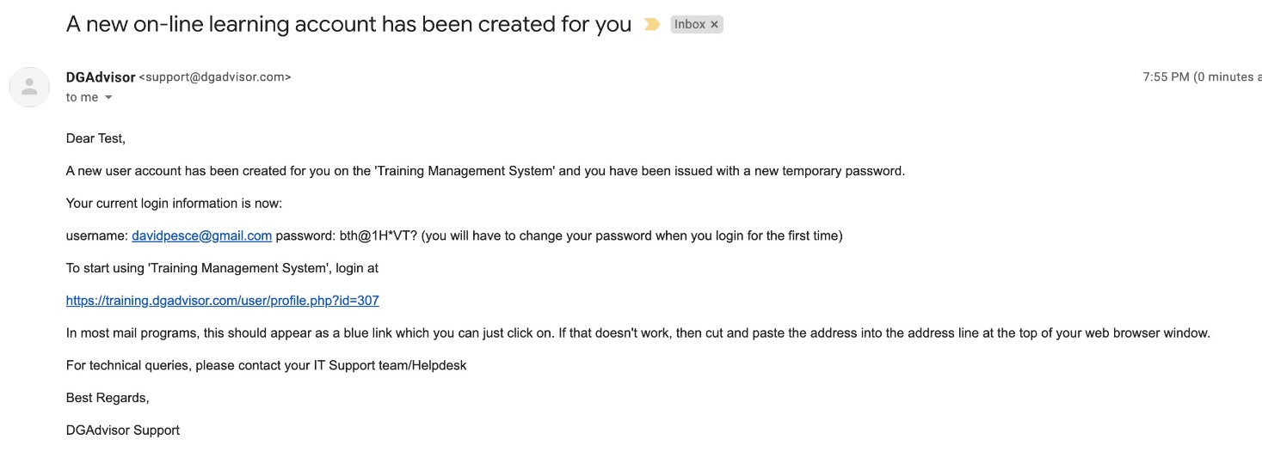
Link

Log in and password

I do not have a company email address.
Open this link in your browser: https://training.dgadvisor.com/login/.
- Enter your username. Your manager will provide this to you.
- Enter the password ChangeMe1
Note: If you are using a shared computer, do not click Remember username.
- Click the Log in button, and follow the directions on the screen.
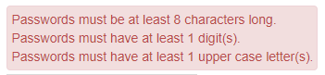 |  |  | 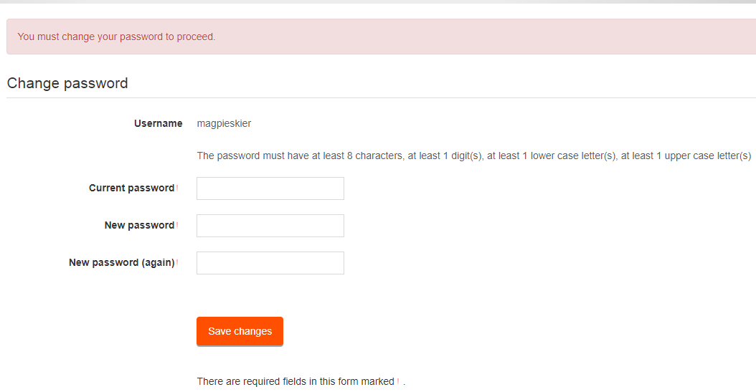
- Click Continue.
- The course or courses assigned to you appear on the Dashboard on the right.
Click the course to open it.
Your progress in the course is shown here.

- If there are multiple modules within they are listed in the order you must take them, and depend on your job compliance requirements.
Note: If you try to take a module out of order, you will be denied until its prerequisite is complete.
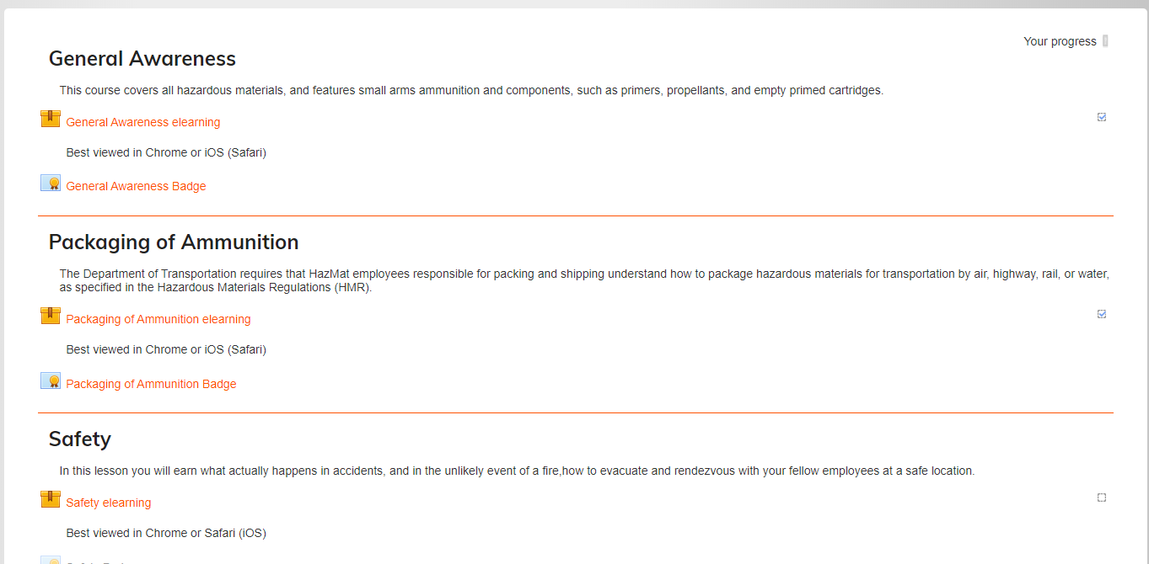

- Click the box icon to access the module. |  |  |  | 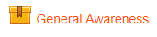
- Click the Enter button to play the course.  Notes:  - Exiting course before you complete it: If you cannot finish the course in one session, that is ok. When you return to it later you see the Resume prompt. Click Yes to resume where you left off.  - Certificates:  - If a certificate exists for the course you will see this icon: .  The link becomes available for opening and printing when you successfully pass the course.  - If you have an email address associated with the course, the certificate is emailed to you upon successful completion. |  |  |  |  | 