Reporting
As a Company Manager, you have access to reports for the employees you manage.
Log into the DGA Training Portal as you normally do: https://training.dgadvisor.com/login/
From the dashboard on the right, click the Reports tab.
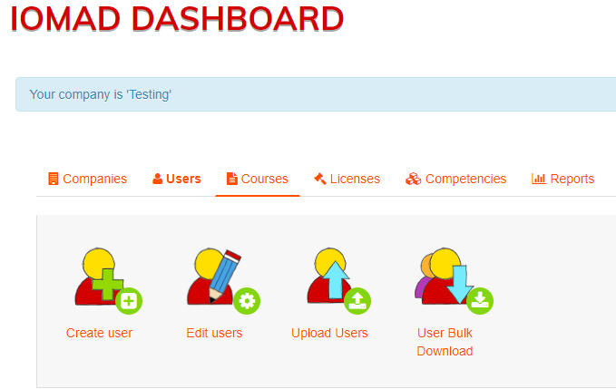
There are several reports shown. The most useful reports are highlighted. The reports that do not apply at all are crossed out.
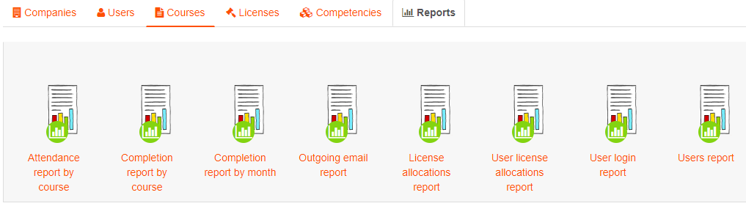
Completion Report by Course
This report lists all the course including the legacy courses (numbered) from the earlier LMS implementation. In the latest implementation, the courses are unnumbered. Scroll down to see them.
To retrieve data from the legacy courses, contact Laura Moats at elearningmto@gmail.com.
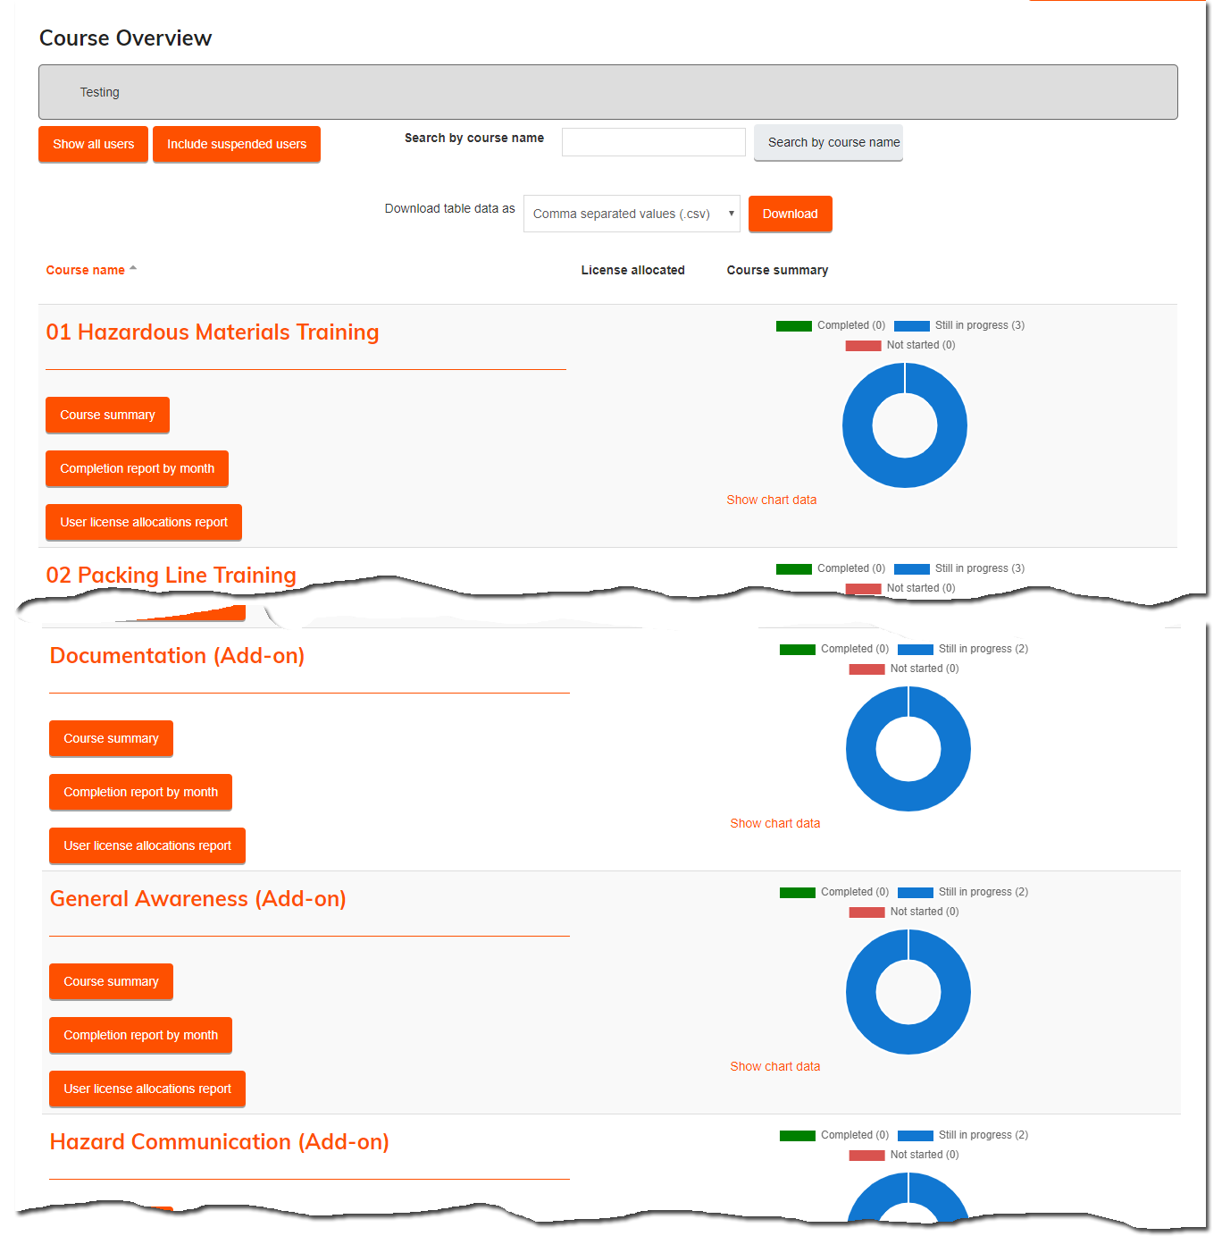
Focus on one course
Grade
Completion status and dates
Each user enrolled in the course
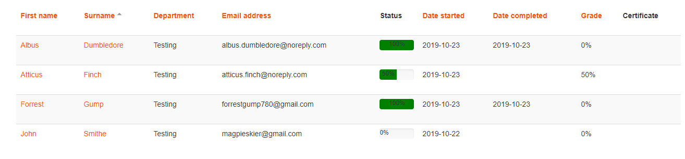
Graphical Summary
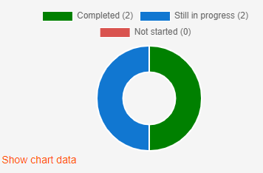

Users Report
This report lists all users in your company.
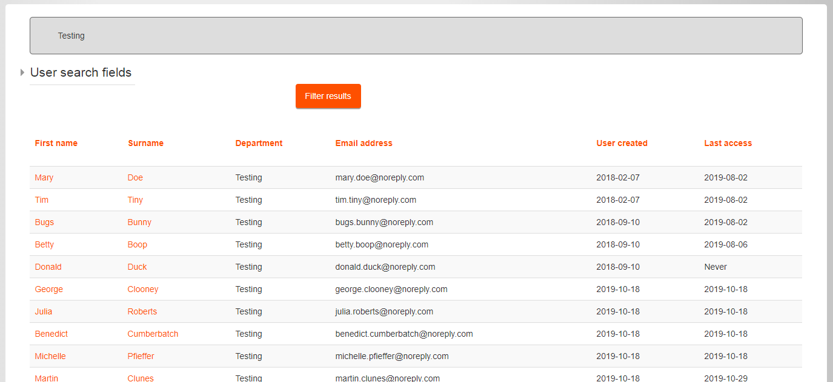
Click a user for details.
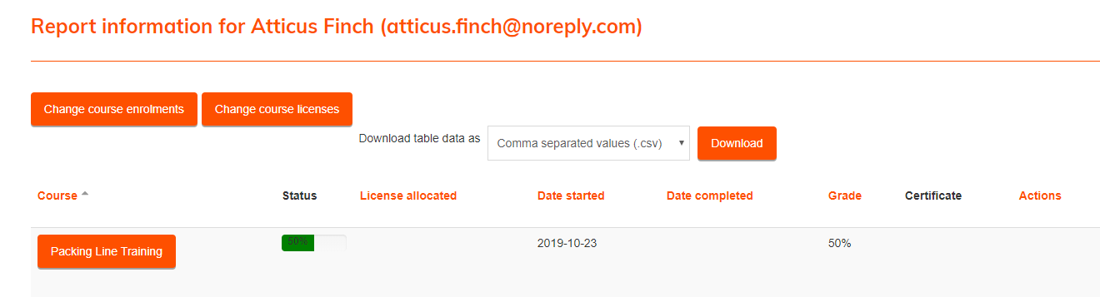
Grade
Start & Completion Dates
Status
Course

